Chapter 1

Introduction

Autonomous vision based robots are intelligent robots which take visual data, process it and provide appropriate output. A robot is a machine that can perform task automatically or with guidance. Here, a robot is designed on Raspberry Pi using OpenCV, which is used for human detection.

1.1 Background and basics
We are living in a modern era where technology has given utmost priority, this makes our life easier. Since safety is the major priority, the safety of house also becomes important this can be done by deploying a robot with human detection capability. Robotics is a combination of computational intelligence and physical machines (motors). Computational intelligence involves the programmed instructions.

Vision is one of the most important senses to a human being and in the past decade there has been an increased interest to use images in robotics. Machines may lack the vast knowledge of object recognition that a human brain can provide but the amount of computational power available in modern times make such machine vision a viable choice of input, and unlike a human eye, machine vision does not degrade over time providing consistent image capture. Images from a colored camera are used in this project as the source of information for processing.

Computer vision is becoming important and with that human detection for applications like video surveillance, autonomous driving vehicles, person recognition have also become important. Human Detection is challenging because everyone is different in appearances and there are wide range of poses.

1.2 Literature Survey
Table 1.1 Summary of literature survey
Title | Published Year | Basic Idea
Human Detection using HOG-SVM, Mixture of Gaussian and Background Contours Subtraction | 2017 | - Human detection using HOG-SVM algorithms
Human Detection and Tracking for Video Surveillance: A Cognitive Science Approach | 2017 | - Detect human beings in any frame.  - Find the movement patterns of the humans in the frame.
Obstacle Detection and Avoidance Robot | 2018 | - Detect and avoid any obstacles in the path.  - Focuses on the edge detection for higher accuracy.
Design and Implementation of an Autonomous Indoor Surveillance Robot based on Raspberry Pi | 2019 | - Identify the person and alert the owner.  - Take necessary actions through the commands given by the owner.
Real-Time Human Motion Detection, Tracking and Activity Recognition with Skeletal Model | 2020 | - Creates human skeletal system based on deep neural networks.

1.3 Project Undertaken

1.3.1 Problem definition
Make a surveillance robot to identify the person, follow him and alert the user. Then, according to the instructions received by user the robot will:
  - Send video to the user through telegram
  - Stop following if the person is known.
  - Return to its original position.

1.3.2 Scope statement
  - This project is undertaken to ensure safety of the house or premise of the user.
  - The project involves surveillance of a premises, in a limited area for a long period of time. It involves communication of robot with the user through telegram.
  - To implement it, there must be successful identification of the person, it’s tracking by the robot and transfer of commands from user to robot for further course of action.
  - Though it is suitable for indoor and outdoor surveillance it is advised to use it in a closed outdoor premise. Also multiple entities are recommended if the area is bigger than the range of camera.
  - While developing this project it was kept under assumption that the robot is placed at a place from where entry/exit of the premise can be easily overlooked.

1.4 Organization Of Project Report

The rest of the report is sorted in the following manner:
Chapter 2 describes about the Planning and management of Project. Chapter 3 presents and explains Design and analysis of the system. Chapter 4 elaborates implementation and coding part of the project. Chapter 5 elaborates testing of the project. Chapter 6 details result and discussions and conclusion and future work of the project is discussed in chapter 7 and 8 respectively. The list of references and appendices is also provided at the end of the report.

Chapter 2

Project Planning and Management

Chapter 3

Analysis & Design

3.1 Introduction
This chapter covers the analysis and design of the considered system. Design of the system is the frame on which the project rests and is then implemented. Analysis of system is as important as design, it gives the overview of the system.

3.2 IDEA Matrix
The Idea Evaluation Matrix is a screening process, a filter and a qualitative decision making tool. It is used to evaluate and prioritize your product or ideas and can be used to illuminate the big issues that need to be addressed by more research and refinement.

While considering this project, a number of ideas were available to choose from hence we created an IDEA matrix to determine the best idea from the given set of ideas.
The matrix contains three ideas namely:
- Person Identification, Communication & Tracking Robot
- Domestic Help Robot
- Home Automation Robot
These ideas were tested on the following parameters:
- Different or Better
- Delivers Value
- Doable, Practical
- Potential for early adopters

A score for each parameter wa sgiven and a matrix was carved out. The final matrix is shown on the next page.

Table 3.1 IDEA Matrix

Scoring | Different or Better | Delivers Value | Doable, Practical | Potential for early adopters | Score
Person Identification, Communication & Tracking Robot | H | M | H | H | 11
Domestic Help Robot | M | H | L | M | 8
Home Automation Robot | L | H | M | H | 9

Table 3.2 Score Classification

Score Category | Score
H | 3
M | 2
L | 1

3.3 Mathematical Model

3.3.1 Algorithm used:
Single Shot Detection algorithm:
Single shot detection algorithm[1] https://arxiv.org/pdf/1512.02325.pdf SSD: Single Shot MultiBox Detector(Wei Liu1 , Dragomir Anguelov) is an object detection algorithm, here it is used to detect humans. It takes only a single shot to detect multiple object present in a image using multibox. In terms of performance and precision for object detection tasks,the single shot detection algorithm scores 74% mAP (mean Average Precision) at 59 frames per second on standard datasets such as PascalVOC and COCO. To better understand SSD, let’s start by explaining where the name of this architecture comes from:
Single Shot: this means that the tasks of object localization and classification are done in a single forward pass of the network .
MultiBox[1]: this is the name of a technique for bounding box regression developed by Szegedy et al. It is a a method for fast class-agnostic bounding box coordinate proposals.[1] https://arxiv.org/abs/1412.1441 Scalable, High- Quality Object Detection Christian Szegedy, Scott Reed, Dumitru Erhan, Dragomir Anguelov, Sergey Ioffe
Detector: The network is an object detector that also classifies those detected objects.

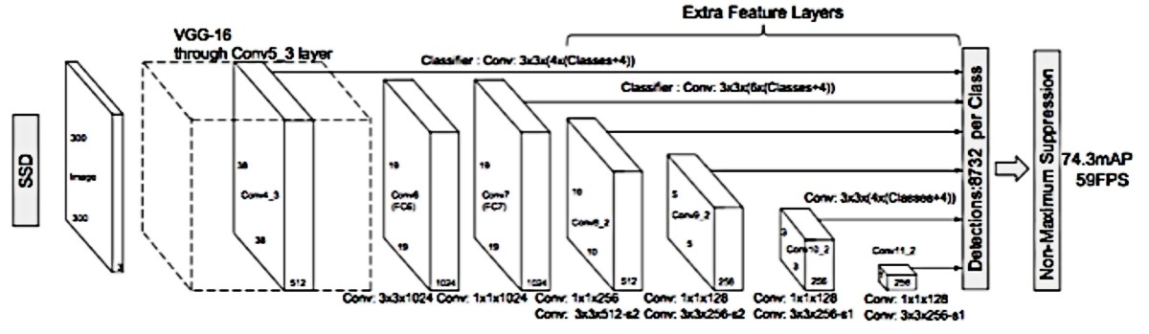
Fig. (3.1) Architecture of single shot detection algorithm
As you can see from the diagram above, SSD’s architecture builds on the venerable VGG-16 architecture, but discards the fully connected layers. The reason VGG-16 was used as the base network is because of its strong performance in high quality image classification tasks and its popularity for problems where transfer learning helps in improving results. Instead of the original VGG fully connected layers, a set of auxiliary convolutional layers (from conv6 onwards) were added, thus enabling to extract features at multiple scales and progressively decrease the size of the input to each subsequent layer. SSD applies a classifier to multiple feature maps. If you perform an appropriate conv operation for each feature map, you get the following results.
(stride = 1, padding = 1) 3 x 3 x (#bounding box x (classes + offset)) / offset: (x, y, w, h)
- 3 x 3 x (4 x (classes + 4))
- 3 x 3 x (6 x (classes + 4))
- 3 x 3 x (6 x (classes + 4))
- 3 x 3 x (6 x (classes + 4))
- 3 x 3 x (4 x (classes + 4))
- 3 x 3 x (4 x (classes + 4)
So, you get a total of 8732 bounding boxes. Not all of these are considered but finally removed through non-maximal suppression. The point to note here is that the convolution layer is used as a classifier rather than considering a lot of bounding boxes. However, the SSD used conv layer to reduce the amount of computation and model parameters to improve speed and reduce model weight.[2] https://wdprogrammer.tistory.com/52
Now, let us see the baisc tenets of multibox method:
The fundamental idea is to train a convolutional network that outputs the coordinates of the object bounding boxes directly. In order to achieve this, the MultiBox loss is the weighted sum of the following two losses:
- Confidence: a logistic loss on the estimates of a proposal corresponding to an object of interest.
- Location: a loss corresponding to some similarity measure between the objects and the closest matching object box predictions. L2 norm is used here( L2 adds “squared magnitude” of coefficient as penalty term to the loss function).
The overall objective loss function is a weighted sum of the localization loss (loc) and the confidence loss (Lconf) where localization loss is the mismatch between the predicted boundary box and the ground truth box and confidence or classification loss is the loss in assigning class labels to predicted boxes. Therefore, the equation for total objective loss is defined in Equation 1.

(1)
Here, x is 1 if the prior is matched to the determined ground truth box, and 0 otherwise, N is the number of matched priors, l is predicted bounding box, g is ground-truth bounding box, c is class, Lconf is condence loss, loc is localization loss, and α is the weight for localization loss. Usually Smooth-L1 loss is used for localization on l and g and Softmax loss is used for optimizing confidence loss over multiple class confidences c.

[3] Scalable High Quality Object Detection https://arxiv.org/pdf/1412.1441.pdf and https://arxiv.org/abs/1512.02325 SSD: Single Shot MultiBox Detector
Wei Liu, Dragomir Anguelov, Dumitru Erhan, Christian Szegedy, Scott Reed, Cheng-Yang Fu, Alexander C. Berg

The alpha term helps us in balancing the contribution of the location loss. As usual in deep learning, the goal is to find the parameter values that most optimally reduce the loss function, thereby bringing our predictions closer to the ground truth.
In MultiBox, the researchers created what we call priors, which are pre-computed, fixed size bounding boxes that closely match the distribution of the original ground truth boxes. In fact those priors are selected in such a way that their Intersection over Union ratio is greater than 0.5. Therefore MultiBox starts with the priors as predictions and attempt to regress closer to the ground truth bounding boxes.

SSD Improvements: Back onto SSD, a number of tweaks were added to make this network even more capable of localizing and classifying objects.
- Fixed Priors: unlike MultiBox, every feature map cell is associated with a set of default bounding boxes of different dimensions and aspect ratios. These priors are manually (but carefully) chosen, whereas in MultiBox, they were chosen because their IoU with respect to the ground truth was over 0.5.This in theory should allow SSD to generalise for any type of input, without requiring a pre-training phase for prior generation.This in theory should allow SSD to generalise for any type of input, without requiring a pre-training phase for prior generation.
- Location Loss: SSD uses smooth L1-Norm (L1 adds “absolute magnitude” of coefficient as penalty term to the loss function) to calculate the location loss. While not as precise as L2-Norm( L2 adds “squared magnitude” of coefficient as penalty term to the loss function), it is still highly effective and gives SSD more room for manoeuvre.
- Classification: MultiBox does not perform object classification, whereas SSD does. Therefore, for each predicted bounding box, a set of c class predictions are computed, for every possible class in the dataset.
Additional observations on SSD:
The SSD paper makes the following additional observations:
- More default boxes results in more accurate detection, although there is an impact on speed
- Having MultiBox on multiple layers results in better detection as well, due to the detector running on features at multiple resolutions
- 80% of the time is spent on the base VGG-16 network: this means that with a faster and equally accurate network SSD’s performance could be even better.
- SSD confuses objects with similar categories (e.g. animals). This is probably because locations are shared for multiple classes
- SSD produces worse performance on smaller objects, as they may not appear across all feature maps. Increasing the input image resolution alleviates this problem but does not completely address it.

3.3.2 Methodology

Different methods for collection, processing and transmission of data were used during the execution of the project. The raspberry pi based robot is the unit for collection of data and it is also the unit for navigation.
Since the raspberry-pi has limited processing power, it was important to do processing in real time without compromising the speed of the robot. Human detection is an important aspect of the project. Communication with the user is also as important. We conduct these processes on a different medium(in this case a laptop). The flow of the execution of methods can described as:
Method of collection of data: The camera on raspberry pi based robot continuously captures images of the local environment and sends it to the processing unit. A UDP connection is established between the two for transfer of data.
Processing of data: The execution of process happens at the processing unit. It looks for any human presence in the image received from the raspberry-pi robot. The Single shot detection algorithm detects presence of human from the image that it gets. It is called single shot because it takes only a single shot to detect the objects present in the frame.
Communication: If there is a person in the frame then the processing unit send the user a message along with the photo of the person through the telegram app and starts following the person till it receives further command from the user.
User control: The user can control the raspberry pi based robot through telegram. The user can tell the robot to stop, send video recording of the person, or return to the original position. The user sends the instructions to the processing unit which in turn directs the robot to execute those instructions.
Also the model is evaluated on the basis of accuracy.

3.3 Feasibility Analysis

Majority of the literature report time complexity of deep learning models in terms of total time taken by the model for training and inference when run on specific hardware. We have used an approximation of the asymptotic complexity to get an idea of which segment of the model takes up the largest amount of time while training and inference. Forward pass of the base CNN is dominated by the time complexity of matrix multiplication. Number of multiplication to perform depends on size of input channel (or image resolution), number of convolutional layers, number of neurons in each layer, number of filters and size of each filter in each layer and the size of output feature map. Except for the input layer, size of input channel and output channel is determined by the number of neurons in each layer. at each layer there is an activation function which can be linear or quadratic based on the function. As ReLu activation function performs element-wise calculation, it runs in quadratic time on each neuron on each layer. All these are parameters or weights to be learned during training. Therefore, runtime of a convolutional model scales linearly with the total number of learnable weights. The total time-complexity of convolution layers for forward pass is as followed,

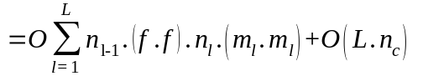

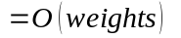

Here, l is the index of a convolutional layer, L is the total number of layers, nl−1 is the number of input channels of the lth layer, f is filter height and width, nl is the number of filters in lth layer, ml is the size of output feature map and nc is number of neurons in a layer which in practice varies for each layer. For training, there is also back-propagation cost which also runs to calculate weights for all the parameters using chain-rule. Thus, timebackprop is also O(weights).

Since the problem can be solved in polynomial time, it can be termed as NP complete. It is feasible to implement the solution of the problem statement.

3.5 Architecture Diagram
3.5.1 Physical Architecture

The physical architecture diagram shows the physical connections in the raspberry-pi based robot. The main unit of raspberry pi is connected to battery and motor driver. The battery provides the energy and motor driver runs the motors controlling wheels. The ultrasonic sensor and camera is also connected to the raspberry pi and they are used for capturing data. Ultrasonic sensor keeps record of distance from nearby objects and camera captures images for processing.

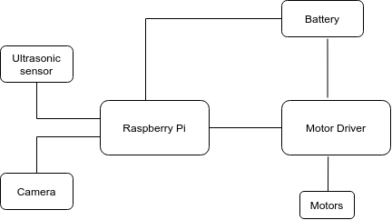

Fig. (3.2) Physical Architecture Diagram

3.5.2 Overview diagram

The overview diagram gives the detailed information of the connections in the system’s physical and logical components. The overview diagram shows the relationship between the raspberry pi and processing unit. The connections between the processing unit and telegram app and between user and telegram app. The overview diagram is given below:

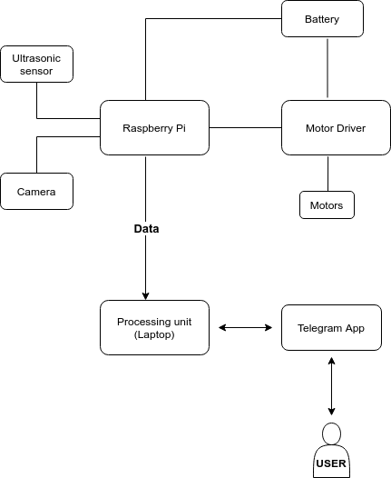

Fig. (3.3) Overview Diagram

3.6 UML Diagrams

3.6.1 Use case Diagram

The use case diagrams model the behavior of a system and help to capture the requirements of the system. The use case diagram for this project focuses on for main requirements of the user from the robot i.e. sending photo, sending video, coming at the reset position and stopping when instructed.

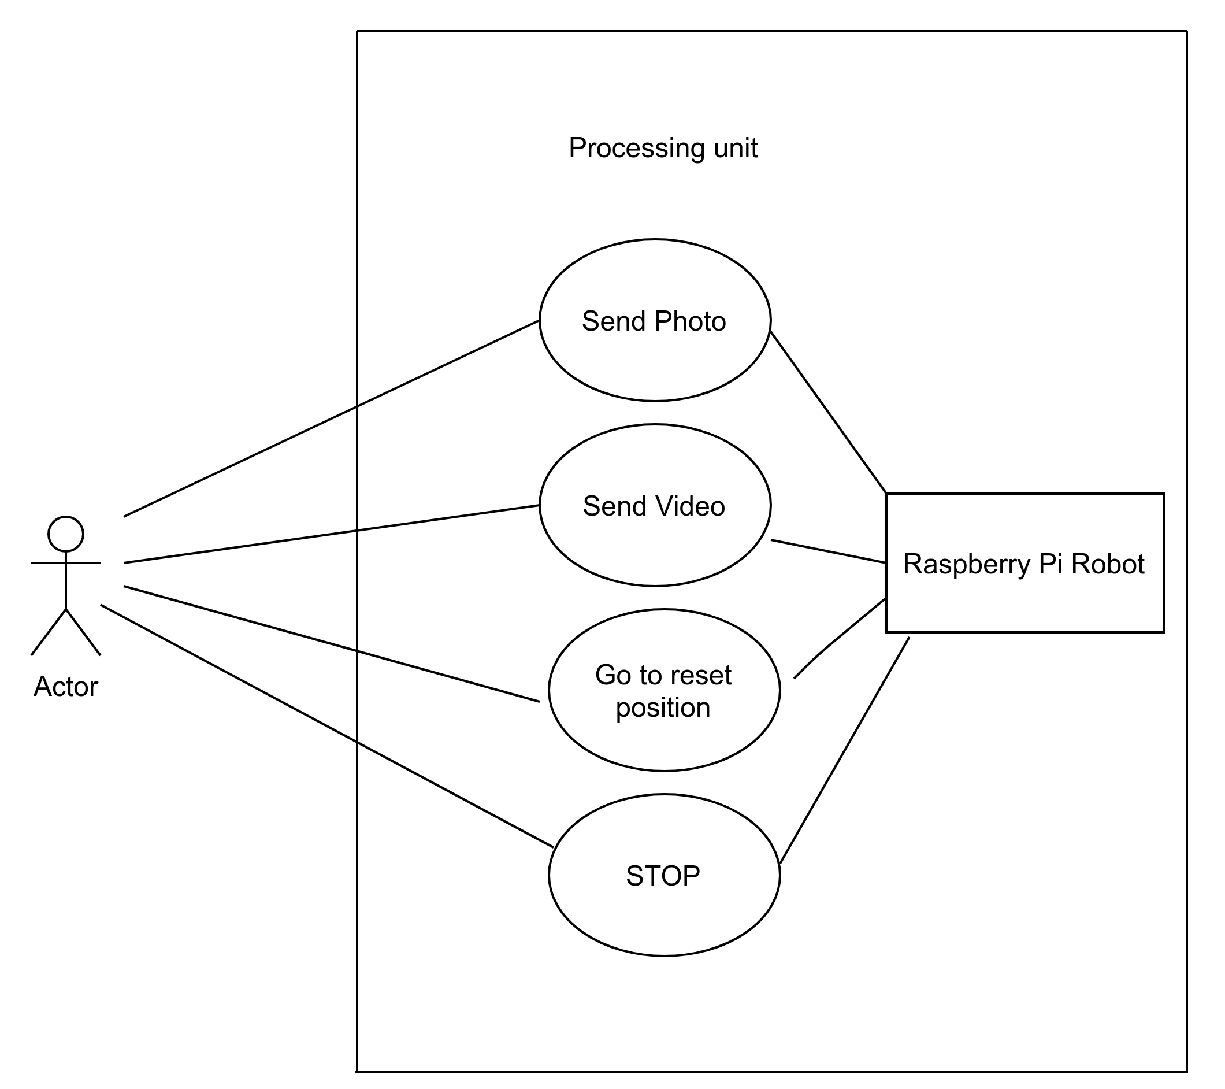

Fig. (3.4) Use Case Diagram

3.6.2 Activity Diagram

Activity diagrams are graphical representations of workflows of stepwise activities and actions with support for choice, iteration and concurrency.
This diagram represents various activities in the system along with the different actions that take place within each activity. It also depicts the flow of the actions within the activities and relation between different activities. The activity diagram is mentioned on next page.

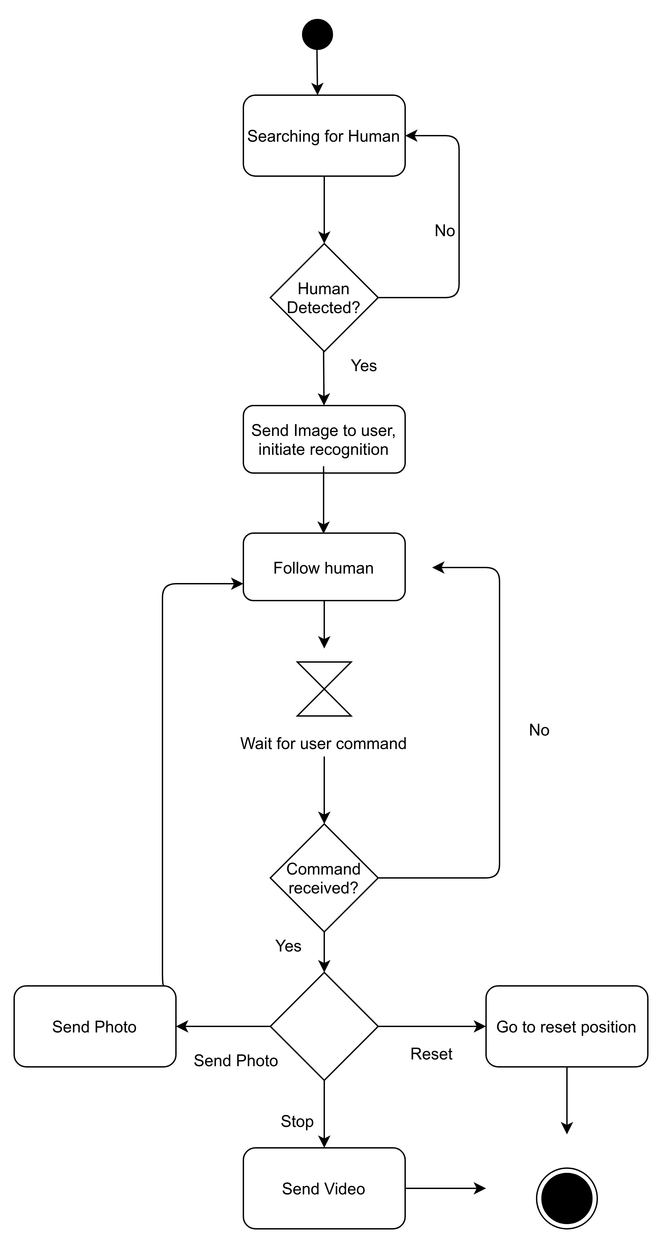
Fig (3.5): Activity Diagram

3.6.3 Sequence Diagram

The Sequence diagram represents the UML, which is used to visualize the sequence of calls in a system that is used to perform a specific functionality. The Sequence diagram shows the message flow from one object to another object. Sequence diagram is used to describe the behavior of several objects in a single use case.
Here, the sequence diagram shows the interaction between the use, the processing unit and the laptop. The sequence diagram is shown on next page.

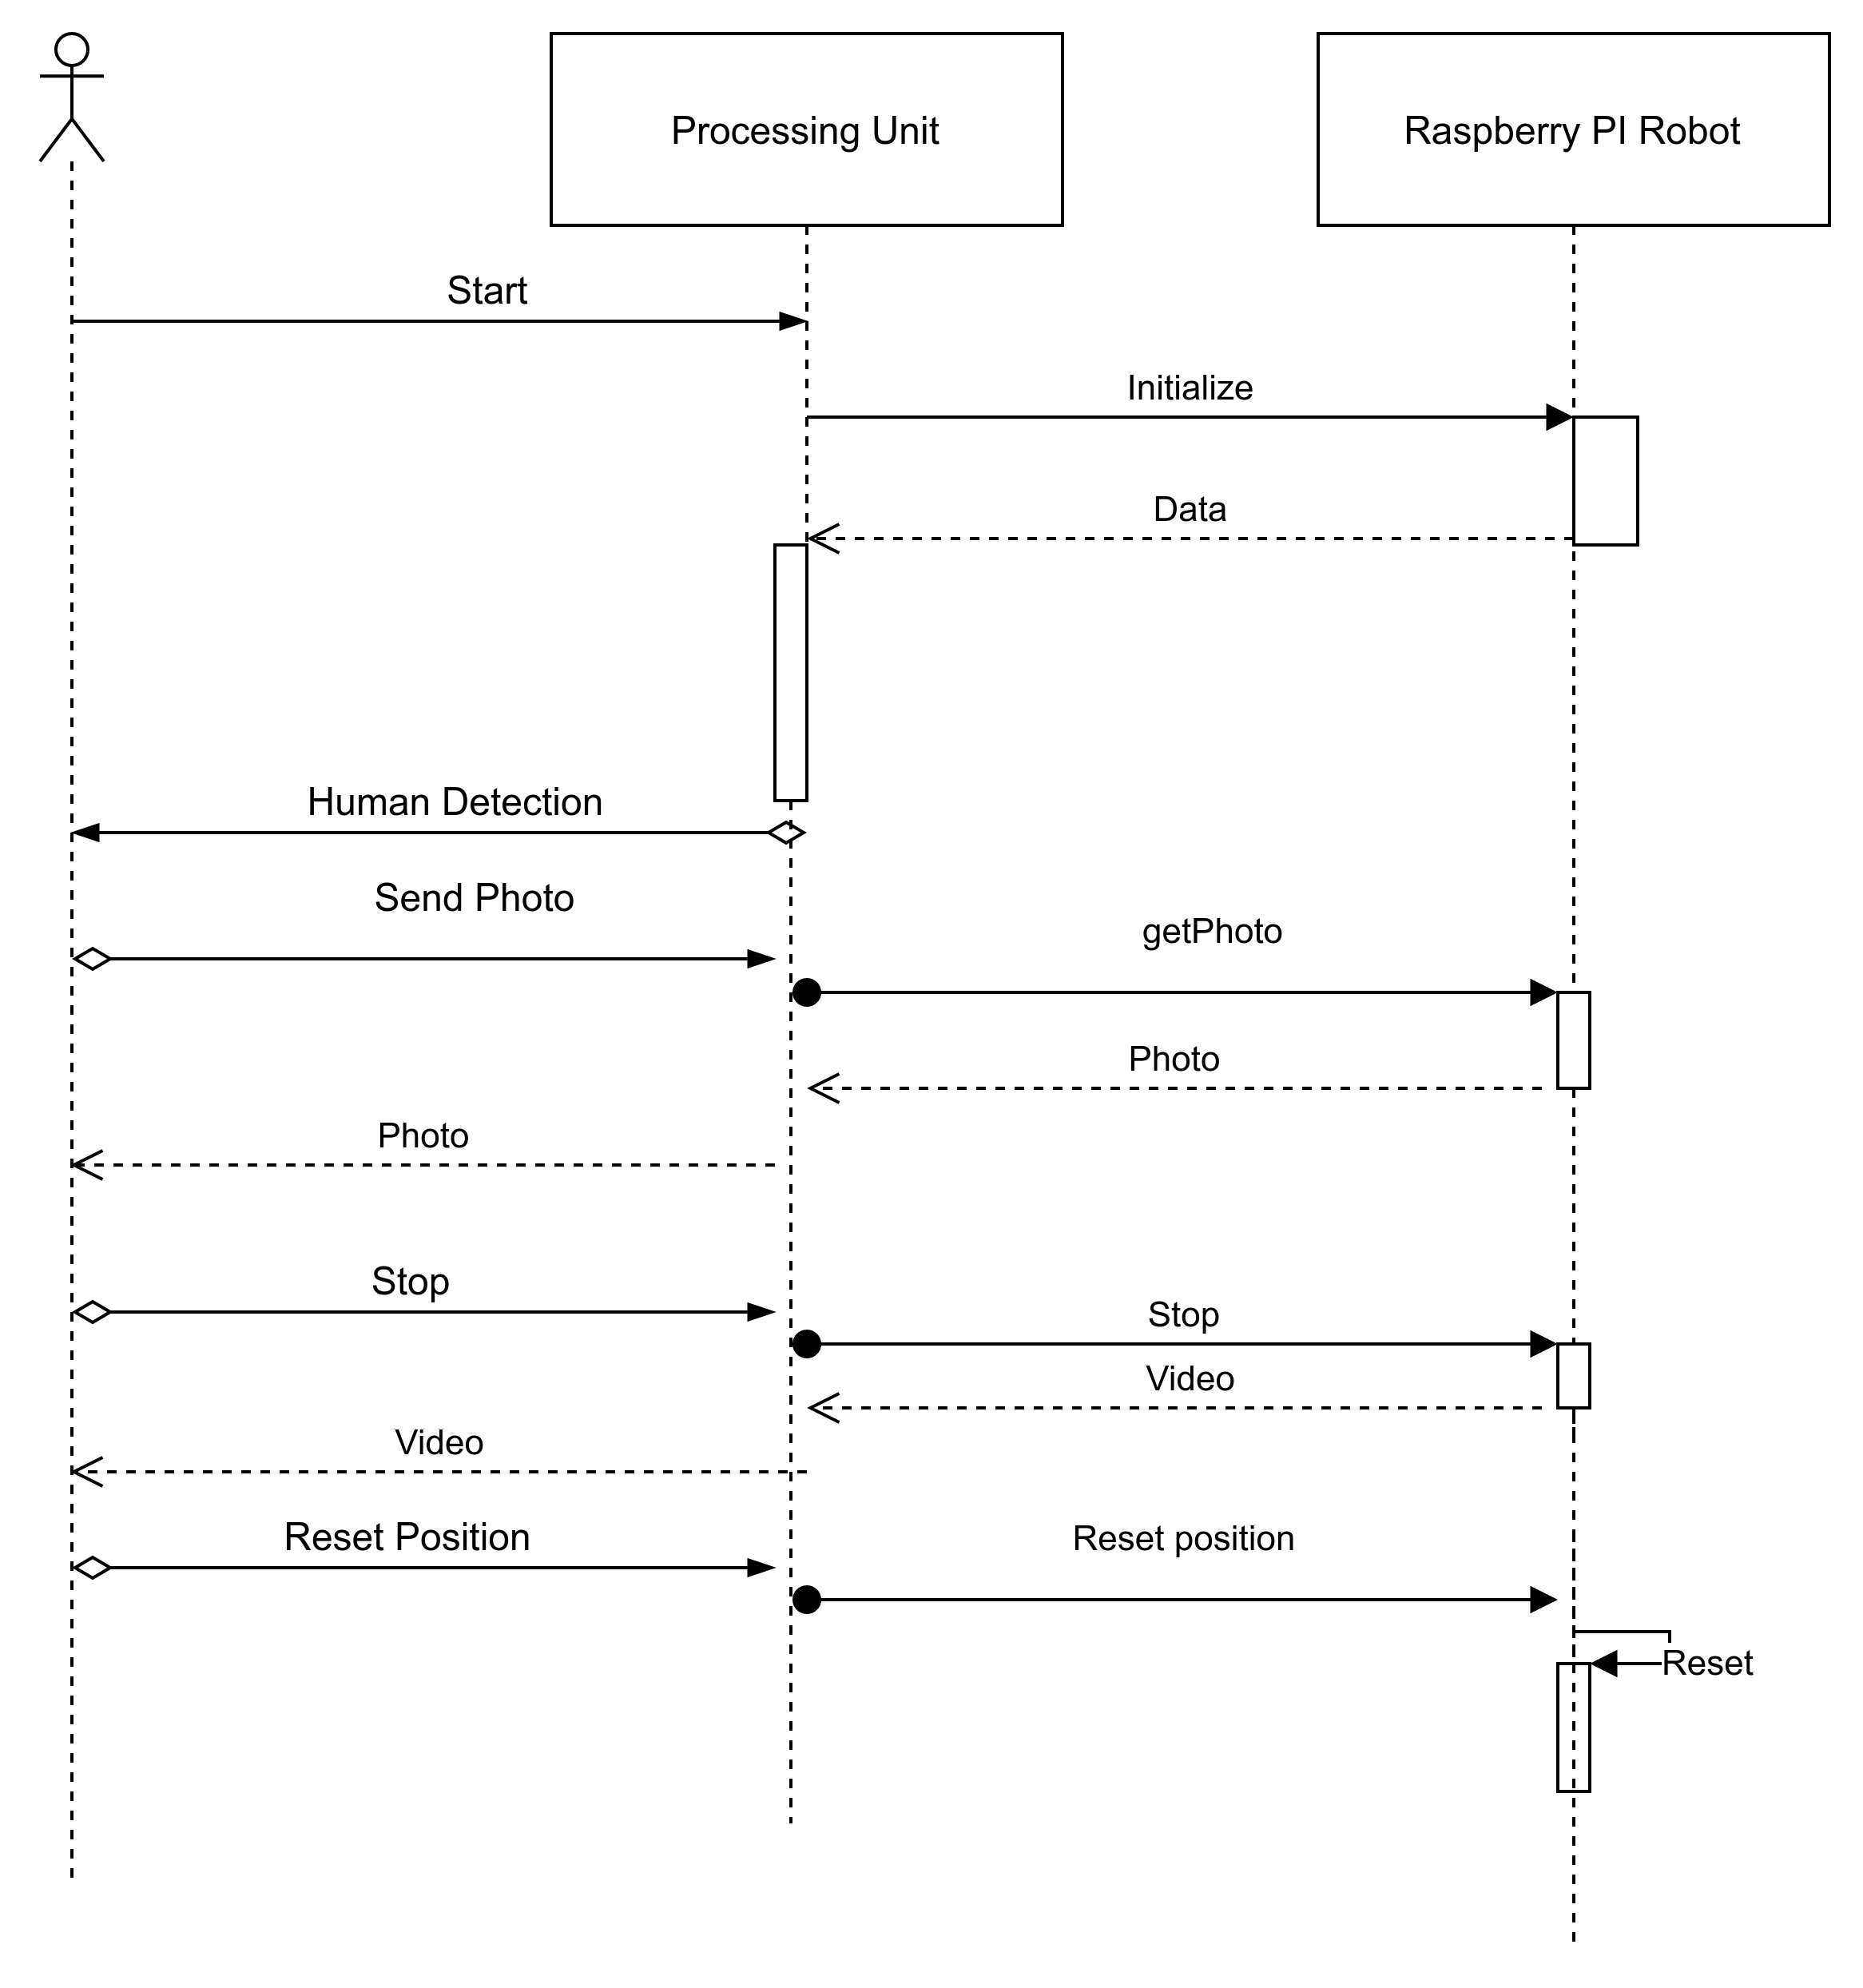
Fig. (3.6) Sequence Diagram

3.6.4 Component Diagram

In Unified Modeling Language, a component diagram depicts how components are wired together to form larger components or software systems. They are used to illustrate the structure of arbitrarily complex systems. This figure shows the interfaces present in the system and their relation.

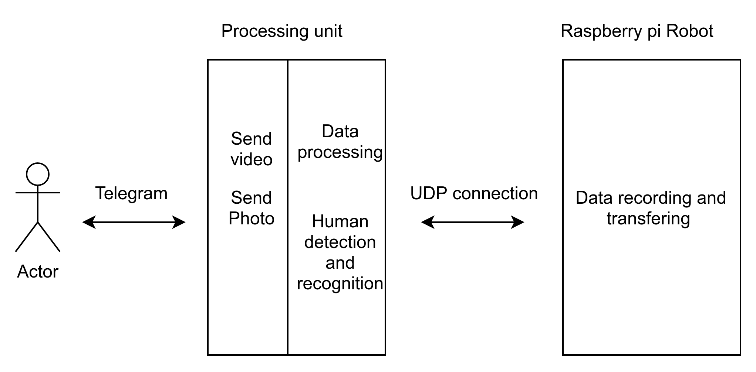
Fig. (3.7) Component Diagram

3.6.5 State Machine Diagram

State Machine diagrams are used to design interactive systems that respond to either internal or external event. State Machine diagram in UML visualizes the flow of execution from one state to another state of an object. The state machine diagram is shown in next page.

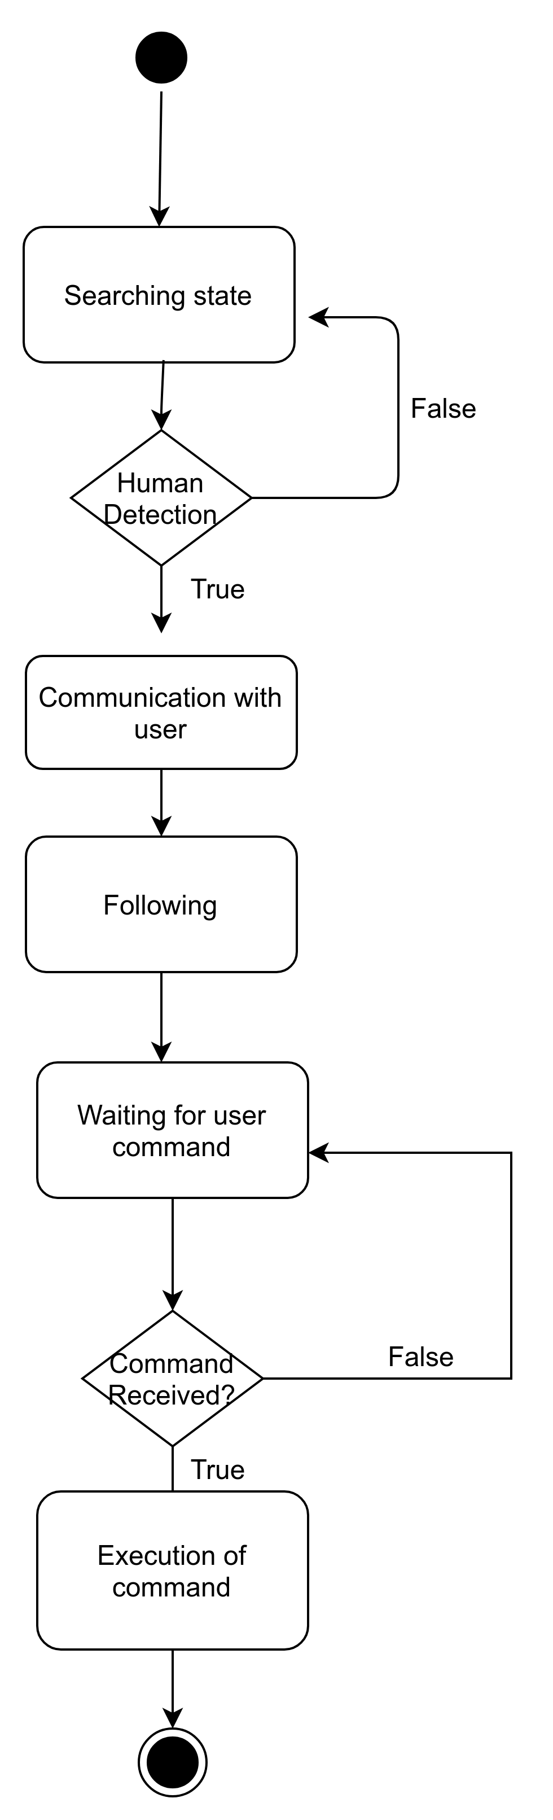

Fig. (3.8) State Machine Diagram

3.6.6 Deployment Diagram
A deployment diagram is a diagram that shows the configuration of run time processing nodes and the components that live on them. Deployment diagrams is a kind of structure diagram used in modeling the physical aspects of an object-oriented system. They are often be used to model the static deployment view of a system (topology of the hardware).

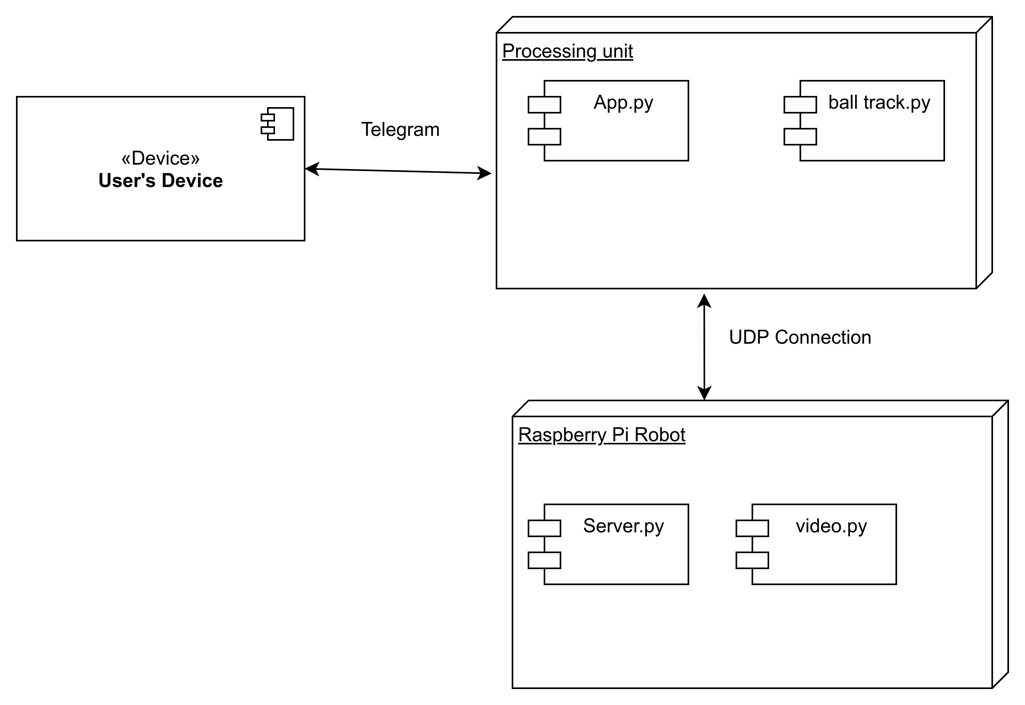
Fig. (3.9) Deployment Diagram
Chapter 4

Implementation & Coding

Chapter 5

Testing

Chapter 6

Results & Discussions

Chapter 7

Conclusion

Conclusion:

Raspberry-pi based devices can help implementing various robots, to increase quality of life of people. These inexpensive machines when programmed correctly can save a lot of money and can be of great use. It is also to be noted that robots are sooner or later going to be an important part of our life just like mobile phones now.

The safety of a house is important aspect of one’s life and this model with can be used in real life situations to cater those needs. The model is also able to communicate with the owner and record things, hence it can be called an addition to the modern day CCTV cameras, it has lower price and better functionality than them.

Project Implementation using the waterfall model was a good choice for a small team, a structured approach was followed during the implementation of this project involving exchange of ideas, sharing of of data, implementation and coding which resulted in successful completion of project.

Chapter 8

Future Work

Future Works

Similar models can be implemented for satisfying other need of the house such as an home assistant, home cleaner, lock based on face detection using raspberry pi based robots. These projects can also be implemented at low cost and will ensure a better functionality than traditional means.

Introducing New Models and Methods:
The current model can also be extended by adding a lot of other functionalities such as verbal communication between owner and model using NLP instead of telegram commands, a separate app for communication with robot, notification by robot when it battery becomes low. Better algorithms can be used as and when they develop for navigation and person identification in the current model.

Porting and Mobilisation of code:
The project was implemented in Python due to its inherent cross-compatibility between multiple Operating Systems It is well known, however, that Python does not best utilize system resources and can result in slower execution and more excessive memory usage than, for example, C++. Whilst implementation of the project in C++ would require OS dependent considerations for OS calls, it might greatly increase the performance of the application.

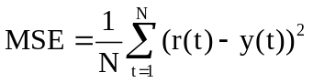 (2.1)
y_{d}
+
u
+
∈
y
G_{m}
F
G_{p}
G_{c}
Fig. (2.1) Block diagram of the Internal Model Control (IMC) scheme

Table 2.4 Summary of the MSE performance of the ANN-IMC and PI

Set point ⁰C | PI Controller  Error | ANN-IMC Controller  Error
30 | 3.58 | 1.76
50 | 20.30 | 18.18
45 | 4.9817 | 3.99
65 | 20.85 | 19.79

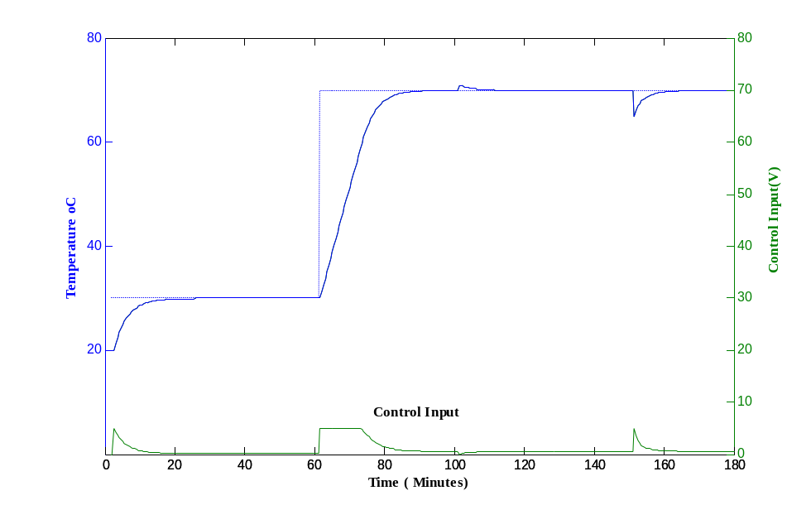
Fig. (2.5) Performance of ANN-IMC controller for set point tracking
TNR 12, bold
Sentence case

